**PaymentWorks**

**New vendor set-up and search for existing vendors**

Effective October 31, 2019 CSUMB, uses PaymentWorks to establish vendors in its payment system, CFS. Vendors will now enter all their information online. This job aid will guide you in the process of establishing new vendors, as well as searching the system for existing vendors.

**Step 1: Entering PaymentWorks**

* Go to Procurement’s CSUMB website: <https://csumb.edu/finance/procurement>
* Scroll down to “New Vendors” and click the link titled “PaymentWorks” (<https://paymentworks.com/login/saml/?idp=csumb>)
* Log in with your Otter SSO

**Step 2: Sending the PaymentWorks “new vendor” link**

* Click “Vendor Master Updates”

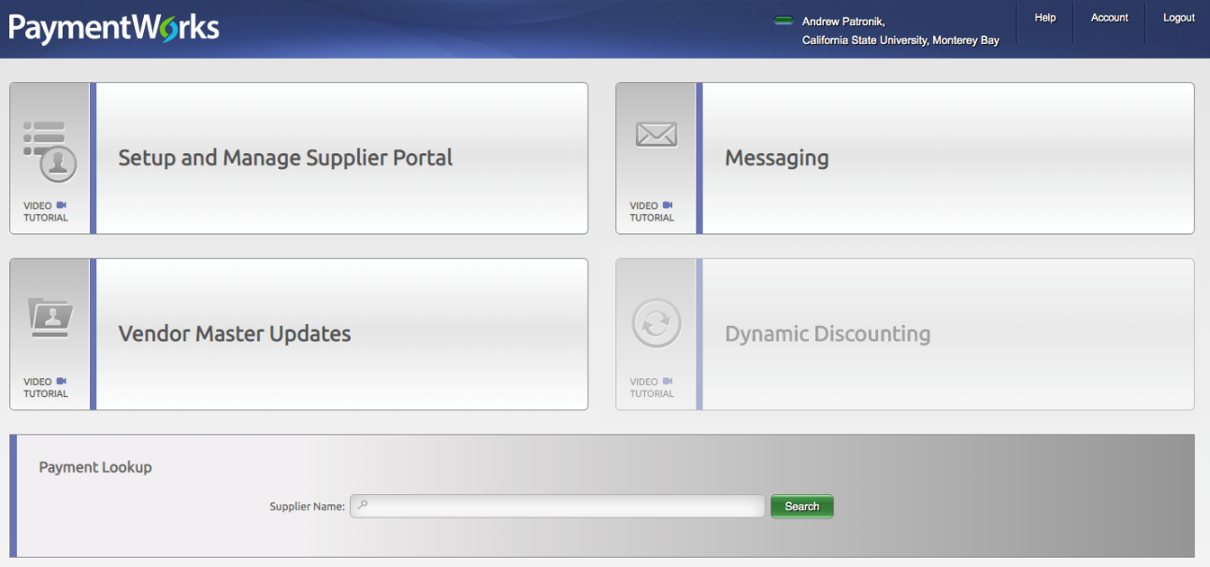

* Then select the tab “New Vendors”

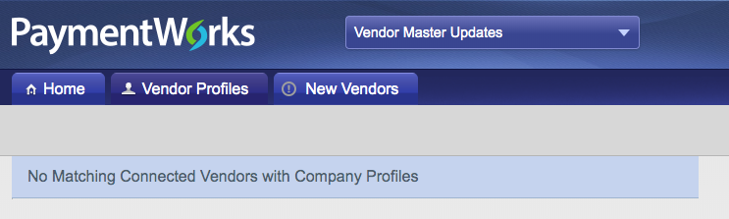

* Click the “Send Invitation” button in the lower left

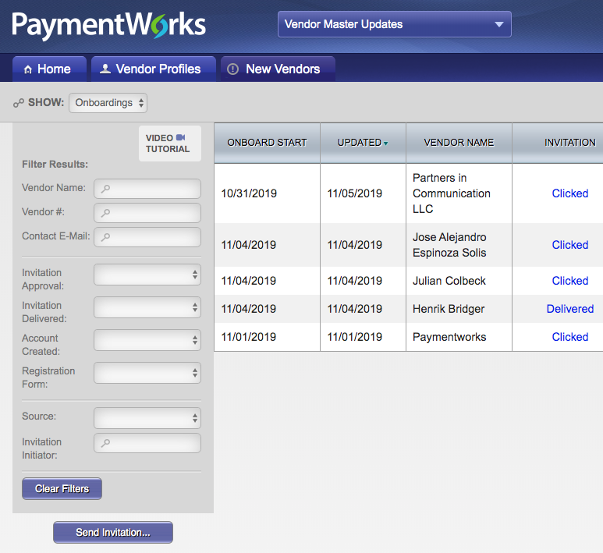

* Enter the vendor’s name and email, as well as your phone number and a brief description of the product or service. Click the “Send” button to email the link directly to the vendor.

**Step 3: Monitoring a new vendor’s set-up within PaymentWorks**

* New, in-progress, vendors will appear in the “New Vendors” tab and display a % completed progress bar. Be sure to follow-up with vendors who fail to register within PaymentWorks, as it will delay payments.
* The following are some status messages you will see for your vendor:
  + *Not Started* – the vendor has yet to create a login/password for their profile
  + *In Progress* – the vendor has created login information but has not finished the registration
  + *Submitted* – the vendor has completed the profile and it is now under review by PaymentWorks staff and/or Procurement
  + *Approved* – review is complete and the information is awaiting input into CFS
  + *Complete* – vendor is officially in CFS (PW will provide the CFS number here)
  + *Returned* – the profile was returned to the vendor, and needs to be resubmitted
* The profile is under the vendor’s control until the status reads “Submitted”. At that point, please allow 3-5 business days for Procurement’s review.
* Until the status says “Approved”, Procurement cannot assist with vendor profiles. Please submit any questions to [support@paymentworks.com](mailto:support@paymentworks.com)

**Searching for Existing Vendors**

Vendors already in PaymentWorks can be viewed to verify remit addresses and vendor ID numbers.

* From the Home screen click “Vendor Master Updates”



* Then go to the “Vendor Profiles” tab to access the full list of vendors and search for specific vendors.

