REMINDER dated 5/4/2015:
University Departmental Receiving Requirements of Merchandise, where Departments had tangible goods shipped directly to them and not to Shipping & Receiving Department (FSO).

By June 15 by noon - Departments are to turn (hand deliver closer to June 15th date) in all their original, signed and dated, receivers (packing slips) to Shipping & Receiving Dept. (FSO).

Remember: In order to be able to accrue, tangible goods must be physically received on CSUMB premise by 6/30/2015, and not enroute to CSUMB. If received in CFS by noon on 6/15/2015 then the system will automatically accrue for you. Do not place on your accrual template if received in CFS by the deadline. Also verify on June 16 against your CFS Departmental Reports to see if the expenditure was process.

Departments have a way to verify if items are received in CFS:
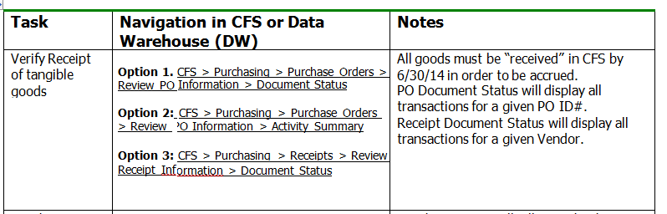

If the expenditure is on your Departmental Reports or you can view received in CFS, then do not place on your manual Accrual Template.

Please always attach a copy of your packing slip to your invoice for items shipped directly to your department, showing items received, signed off and dated.
See http://finance.csumb.edu/accounts-payable for University Departmental Receiving Requirements Procedures for specific and complete instructions. These instructions detail what to do when there is not a receiver.
Please make sure the approved packing slip copies that you forward to Accounts Payable (AP) display:

- CSUMB Purchase Order Number (PO #); or ‘NO PO’ stated
- Invoice # (if available)
- Date received by the department
- What items have been received
- Clearly state what items have not been received
- Clearly state what items will be returned to the vendor, and the reason for returning
- State the reason why the items were received by the Department, instead by Central Receiving
- Printed and signed name of the person receiving on behalf of the Department

Without a packing slip or an inventory listing of what was received by the Department, Shipping & Receiving Dept. (FSO) will not receive into CFS.

After noon on 6/15/2015, Shipping & Receiving Dept. (SFO) can no longer receive tangible goods in CFS for FY14/15. Receiving in CFS will start in early for FY15/16 and only for merchandise received after June 30. Merchandise received after 6/15 (noon) will be manually received (*exception override by AP required) and S&R (FSO) will send copies of the receivers to Accounts Payable as proof of receiving by June 30, 2015. Departments will have to manually accrue, projecting for the time frame between 6/115 noon through to 6/30/2015, only if goods guaranteed to be on campus (not enroute) by 6/30/2015. Attach this guarantee to the approved invoice. Remember to only accrue if expenditure is not already sitting in the GL.
*Accounts Payable will override ‘receiving required’ within CFS in order to voucher and pay in FY15/16 against PO (3-way match) that were manually received for FY14/15.

In order for Accounts Payable to match the packing slips to Purchase Orders and invoices, please cross reference, i.e. denote PO # and Invoice # (if known) on the documents. To be more specific, AP is looking for packing slips received by 6/30/2015. These packing slips are verified against the order received by the Department as required proof that goods and services have been received by 6/30/2015.

Prior to noon on 6/15/2015, when receiving is required (3-way match PO) and the Department receives the goods directly, the Department must email a request to Benny Sanchez in Receiving, with a carbon copy (cc) to Accounts Payable – accounts_payable@csumb.edu, to record the receiving. Attach the packing slip or inventory listing to this email denoting what was actually received, etc., following the receiving instructions above. When sending the approved invoice to Accounts Payable, attach a copy of this packing slip for quicker processing. Reminder: All original packing slips need to be forwarded to S&R after inventorying shipment. For ProCard accruals you would do same, attach approved receiver but this type of accrual is handled differently than AP accruals. See the weekly announcements or the year-end instructions and YE Memo with instructions at http://finance.csumb.edu/finance-home which include ProCard and Use Tax instructions.

It is critical that you follow these instructions, especially at year end. The benefit to you is that if tangible goods are received in CFS by 6/15 at noon, then Accounting will automatically accrue for you and SAVE YOU TIME.

Terminology: Receiver is a packing slip.

