MANAGING TRUST PROJECTS

Trust projects are unique in that they are more akin to a business activity than activities that are state supported by the general fund or other appropriations. Rather than relying on budgets for determining what funds are available, management of trust funds requires analysis of cash, investments, and fund balances to determine what true resources available. As such, management of trust funds requires different tools and techniques.

TRUST AGREEMENT

Trust projects are created based on a demonstrated need and statutory authority. The purpose, approved signers, statutory authority and other important information is documented on a Trust Agreement. The trust agreement also contains the PeopleSoft Fund chartfield(s). Since trust projects represent unique activities, a copy of the trust agreement is necessary to understand and manage a specific trust project. Copies may be obtained from the Budget or Accounting Departments.

TRUST REQUIREMENTS

Trust funds are state funds and most of the rules governing their use are identical to those affecting the General Fund. The trust manager must monitor the activities of the trust project to ensure that:

- revenues and expenditures are authorized by the trust agreement and any governing statutes, executive orders, policies or procedures. Of special interest is the hospitality policy and travel policies which are both applicable to trust funds;
- it is self-funding, meaning that it generates sufficient cash to meet all cash flow needs at any point in time; and
- it is self-supporting, meaning that it fully reimburses other funds for all expenditures made on behalf of the trust project activities.

MANAGEMENT TOOLS

The primary tools for monitoring the requirements are discussed briefly below:

- Authorized – The Trust Agreement is used to identify the basic types of transactions that are authorized within a given trust project. Depending on the type of proposed transaction, it may be helpful to also refer to the CSU’s hospitality policy, travel policy or the cited Education Code (see references below). Unusual transactions may also require consultation with Accounting Department staff.

- Self-Funding – The PeopleSoft nVison Report “Trial Balance By Fund” is used to determine the cash position of a trust fund at any given point in time. (sample attached). The total cash balance is calculated as the total of all cash, investment and fund balance clearing accounts (shown in yellow on the sample). Accounts to include are:

101001 General Cash
101002 Agency Trust Fund Cash
101003 Revolving Fund Cash
101008 Cash with Fiscal Agents
101009 Cash on Hand
101010 General Cash-Remittance-Transt
101800 Cash in Bank - Operating
101801 Cash in Bank - Payroll
101802 Cash in Bank - Grants & Contra
101803 Cash in Bank – TouchNet
105027 Investments - MetWest
108800 Investments - Money Market
108801 Investments - Short Term
108802 Investments - Total Return
108803 Investments-Medium Term
305022 Fund Balance – Clearing Account

The sum of these accounts for a given project should result in a positive amount. If the amount is a negative number, corrective action should be taken. Corrective action may include obtaining additional revenues, collection of receivables, or transfer of expenditures to another fund.

Note: If the trust project being analyzed contains multiple PeopleSoft funds, the aggregate of all funds is calculated rather than each one considered individually for the purposes of this test.

- Self-Supporting – The Trust Project’s fund balances can be calculated by summing the Total Assets, Total Liabilities and the Fund Balance – Clearing Account as shown on the PeopleSoft nVison Report “Trial Balance By Fund”. This should result in a positive number. If not, corrective action is required, such as billing additional revenues or transferring expenditures to another fund.

The calculation of the sample equity would be:
Total Assets $64,000
Total Liabilities (50,000)
Fund Balance - Clearing 305022 100,000
Total Equity $114,000

Note: If the trust project being analyzed contains multiple PeopleSoft funds, the aggregate of all funds is calculated rather than each one considered individually for the purposes of this test.

Note: Careful monitoring of encumbrances (purchase orders and other contracts) and outstanding receivables is necessary to avoid overdrafting the trust project as they only impact the above calculations when cash is received or disbursed.

DEFINITIONS (for purposes of this discussion)

- Trust Requirements: A list of controls that are different from general fund activites, mandated by statutes, executive orders or systemwide policies.
- Trust projects: An activity tracked within a single or group of trust funds
- Trust Agreement: The document authorizing a trust project. It contains relevant information such as purpose, legal authority, authorized signors and approvals.
- Trust manager: The person assigned to monitor trust project activities, generally the departmental budget analyst.
- Statutory authority: The law(s) that specifically allow the University to engage in a specific type of activity. As a state agency, the University is prohibited from engaging in any activity that it has not been granted authority under law. For trust projects, Education code 89721 is the generally the primary authority.
- Self-funding: Cash generated by the trust project are sufficient to meet its cash needs at all times. Evidence of this is that the cash balances remain positive.
- Self-supporting: Revenues generated by the trust project are sufficient cover its expenses. No augmentation of revenues is provided by other funds (except as reimbursement for goods and/or services provided to those funds) . Reimbursements will be made for any expenses made by other funds on behalf of the trust project.

DISCLAIMER

The above is intended to be a brief discussion to assist trust managers understand the basic principles of trust project management. Please contact the Accounting Department to discuss specific questions or needs.

REFERENCES:

Trust Agreement Form (blank)

EO 761 Hospitality Policy

HR 2005-42 – Travel Policy

Education Code

PeopleSoft page setup to run “Trial Balance by Fund” report:

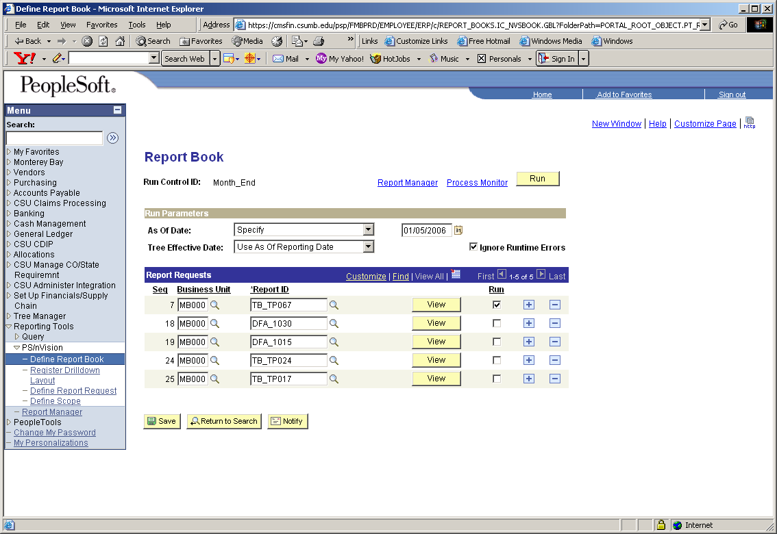

Specific help running PeopleSoft reports is available on the CMS website at: http://cms.csumb.edu/site/x4234.xml
SAMPLE Peoplesoft nVision Trial Balance by Fund

